

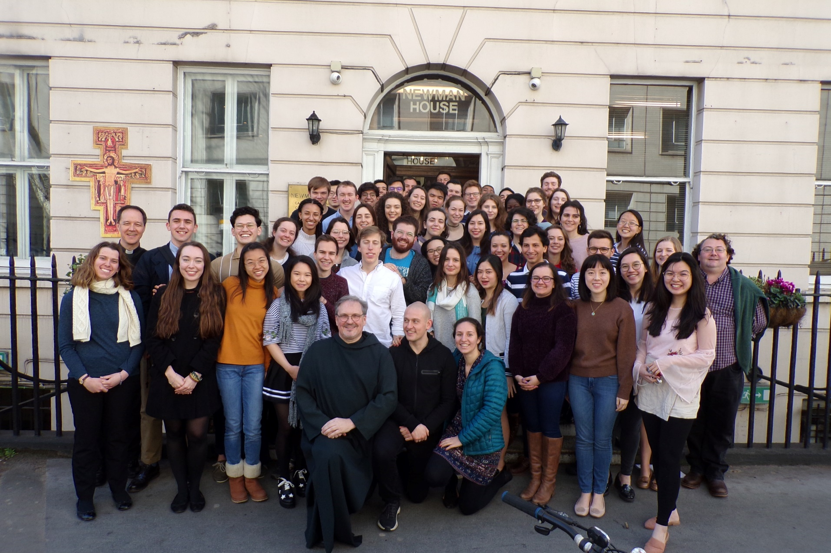

|  |
| --- |
| **Application For Residence**  Before completing the form and returning it to Newman House by email, **please read** all accompanying notes. Your application **must** be accompanied by the following supporting documents.   1. A letter stating why you wish to live in Newman House, and what contribution you would make to the life of the community. 2. Two written references, one of which should be from your Parish Priest or College Chaplain. 3. A recent passport-sized photograph of yourself. Please insert it into the box provided in the form.   Applications will not be considered until all accompanying documents have been received.  **PLEASE SUBMIT ALL DOCUMENTS BY EMAIL** |



**111 Gower Street**

London

WC1E 6AR

020 7387 6370

|  |
| --- |
| Dear Student,  Newman House is *both* the **Catholic Chaplaincy for university students** in Central London and a **small residential hall** which offers students a unique opportunity of living for one year in an adult Catholic community.  We are pleased to provide you here with information about *living* at Newman House. The past academic year has again been a challenging one because of the ongoing disruption of the pandemic. But it has made us appreciate the benefits of living together in a supportive community of faith. In the new academic year (2022–23) we will continue having Newman House fully open, building on the successes of the year just gone. There is a very rich community life at Newman House, which is then the hub of the wider, welcoming Chaplaincy.  Newman House is *far more* than just another hall of residence. In many ways we are quite demanding of the students who live here. In order for Newman House to retain and build upon its ethos as a *Catholic* residential community, we expect applicants to be those who want to participate fully in the community and spiritual life of the House. For our part, we will seek to help you to develop your experience of the Catholic Faith in a way that is positive and enriching. We base this upon the three pillars of *community, spirituality and mission*.  In order to achieve these aims, you need to know that the following are understood, at the outset, to be part of the *normal commitment* of those who are resident at Newman House:   1. That you would be regular in your **attendance at Mass in the Newman House Chapel** on Sundays, i.e. that you will regard it as your *parish* for the Sundays of the year. 2. That you make a commitment to **take part in at some of the activities for formation**, and the development of your spiritual life. 3. That you be regular in your **commitment to one of the House Jobs** allocated to residents.   If this opportunity of residing in a Catholic community attracts you, and you feel called to take on these commitments above, please complete and return the attached application form. Note that applications for residence must be for the *full* 2022–23 academic year, i.e. for a **minimum of 39 weeks**.  If you wish to find out more about living at Newman House, please feel free to visit us, and I, or Chris Castell will happily discuss it with you. God bless you as your pray and reflect on committing yourself to a faith-filled year at Newman House.  Fr Philip Miller  *Senior Chaplain* |

|  |
| --- |
| **Newman House Catholic Chaplaincy: Information for Applicants** |

Newman House is both the centre for the Catholic Chaplaincy to London’s Universities, and a small residential hall which offers students a unique opportunity of living for one year in an adult Catholic community. Situated in the heart of London’s student district, Newman House provides 65 residential places.

|  |  |
| --- | --- |
| **Included in the Rent:**   * Accommodation in a single bedroom, with desk, sink and washbasin, and the usual furnishings for a bedroom, for a minimum of 39 weeks. * Breakfast and main meal each day of the week. * Shared Bathroom facilities * Utilities (water, power, etc) * Use of shared areas: Chapel, Library, TV Room, Bar, Garden Area, Iron. * VAT * Wireless broadband | **Additional Facilities**   * Card operated Laundry facilities * Bar   **You should bring:**   * your own bedding and towels, * plates, mugs, cutlery etc, for use outside the catered meal times. |

**Residence Period & Payment of Fees**

* Accommodation is only offered for a **full academic year of 39 weeks**. Once you have been accepted as part of the residential community at Newman House, you are liable for the fees for the full 39 weeks. These are listed in the box below, and are payable in advance at the beginning of each term.
* A deposit of £400 is payable to confirm you have accepted the offer of a place. This is returnable at the end of the year provided the keys have not been lost or damage been done to the property.
* Normally rooms must be vacated at the end of the Academic Year, but arrangements may be made for students whose studies continue beyond that time.
* **No responsibility is taken for the loss of personal property**. Students should provide their own insurance cover.

**Residents are expected to take a full part in the running of the House, including the Chapel, thereby making Newman House a welcoming place to non-resident visitors and guests.**

|  |
| --- |
| **Before completing the form, please note**  Newman House is a Catholic residence for full-time students at one of the London universities.  There are a limited number of places available, and in order to give the best possible experience to residents, it is important that everyone is committed to the life of the community.  If you are considering applying to live here for the Academic Year, we draw your attention to the following:   1. Our primary responsibility is to the Catholic Community, and, as such, it is seldom possible to offer places to people who are not Catholic. Catholic students who apply are expected to be committed to their faith and to make Newman House their main place of worship. 2. We are only able to accept those **enrolled in a course of full-time study at a university or institute of higher education.** 3. Applications must be for a full 39 weeks. 4. We only accept those who are under 28 years of age at the beginning of the Academic Year. 5. Priority is normally given to students who are **not** first year undergraduates.   We regret that we are not usually able to offer places to applicants who are ordained, members of a religious order or married. |

|  |
| --- |
| **Weekly room rates for the full Academic Year 2022-23**  (for a minimum period of 39 weeks)  Bandings are calculated on a scale based on size, location and other factors.    BAND A £230.00  BAND B £225.00  BAND C £220.00  *Fees are payable in full within two weeks of the start of each period of residence.*  **These rates apply from 1st September 2022 until 30th June 2023**  **The Newman House Term Dates are**   * **TERM 1** Saturday 10th September – Saturday 24h December * **TERM 2** Saturday 24th December – Saturday 18th March * **TERM 3** Saturday 18th March – Saturday 10th June |

|  |
| --- |
| **Summary of the Newman House Licence Agreement** |

|  |
| --- |
| 1. Residents’ rental commitment is for a minimum of a 39-week academic year, divided into three periods of residence (semesters or terms). 2. Residents commit to fulfilling their house job as an integral part of their place in Newman House. 3. Residents make a commitment to take part in the life of the Chaplaincy community, taking advantage of the opportunities provided to deepen the life of faith. 4. Rents are charged for the full license period; there is no rebate for late arrival or early departure. 5. Rent for each period of residence is payable in full at the commencement of each term. 6. If you vacate your room in Newman House during a period of residence there will be no refund of rent paid for that period. 7. In cases of hardship or difficulty, the Finance & Operations Manager will always be willing to meet with individual students to seek a solution. 8. Any resident who is found to be in breach of the Licence Agreement, or to be causing undue disruption in the House will be asked to leave.   PLEASE NOTE  If you are offered a place, you will be required to sign a Licence Agreement, and to pay a deposit of four hundred pounds (£400) to confirm your intention to take up residence. This deposit is not refundable if you cancel.  If you lose your keys, you will be charged for replacements, which may entail locks being changed.  At the end of your stay your deposit will be returned to you when you return your keys, providing there has been no damage to Newman House property and your room has been left in a clean state. |

**Newman House**

*Application for Residence 2022-23*

Complete all the coloured boxes.

|  |  |  |
| --- | --- | --- |
| **BASIC INFORMATION** | | |
| Family Name |  | *Insert Photograph in the box below* |
| Christian Name |  | http://shackmanlab.org/wp-content/uploads/2013/07/person-placeholder.jpg |
| Date of Birth | (DD/MM/YY) |
| Personal Email |  |
| College Email |  |
| Mobile |  |
| Sex |  |
| Nationality |  |
| Religion |  |

|  |  |  |  |  |
| --- | --- | --- | --- | --- |
| **YOUR COURSE OF STUDY** | | | | |
| College |  | UG or PG | |  |
| Degree (BA, MSc, etc) |  | Year of Course in 2022-23 | |  |
| Subject |  | Previous University  (if any) |  | |

|  |  |  |  |  |  |  |
| --- | --- | --- | --- | --- | --- | --- |
| **PERSONAL INFORMATION** | | | | | | |
| Permanent Home Address | | | | Correspondence Address (where this is different) | | |
| Valid Until | |  |
|  |  | | |  | |  |
| **Next of Kin** |  | | | Relationship to you | |  |
| Phone |  | | | Email | |  |
| Please give details of any disability, serious allergy, or other ongoing medical condition. | | | |  | | |
| Specific Dietary needs (if these are due to a medical condition, please provide a medical certificate) | | | |  | | |
| Have you been vaccinated against Covid-19? | | | | YES/NO | | |
| Are you willing to receive the vaccine if it is offered to you? | | | | YES/NO | | |
| **ABOUT YOU** | | | | | | |
| Tell us about your Hobbies, Activities and Interests | |  | | | | |
| Any recent Work Experience | |  | | | | |
| Will you be working during the coming Academic Year? | |  | | | | |
| Do you play a musical instrument? If yes, please tell us the standard to which you play. | |  | | | | |
| How did you hear about Newman House? | |  | | | | |
| Have you previously lived in a University Chaplaincy? | | YES/NO  (delete one of these) | If yes: which? | |  | |
| If yes: between what dates? | |  | |
| Are there other gifts or skills you could offer to the community? | |  | | | | |

|  |  |  |  |
| --- | --- | --- | --- |
| **Room Band Preference** (A-C), please state in order of preference |  |  |  |

|  |  |  |
| --- | --- | --- |
| **HOUSE JOBS**   * All residents are required to undertake one of the following House Jobs in order to help with the running of the Community. * Please select **FOUR** jobs you would like to undertake, ranking them in order of preference (1-4), and you will be allocated one of these. | | |
| **Chapel & Sacristy** | **Serving at Mass:** Preparing the Chapel for Mass and Serving on Sundays and Weekdays |  |
| **Choir:** Singing at the Sunday Morning Mass |  |
| **Sacristy Team:**  Buying and arranging flowers, polishing the silver, ironing the linen, or wiping down the backs of the chairs with disinfectant after Mass (you would be assigned one of these jobs) |  |
| **Ministry of Welcome:** Welcoming people to Mass on Sundays and helping to co-ordinate rota of readers. |  |
| **Hospitality** | **Preparing Coffee** after Mass on Sundays and for other events, and welcoming visitors |  |
| **Bar** | **Staff:** Serving behind the Bar on a Rota basis |  |
| **Social Media** | Updating the Chaplaincy Social Media feeds each day |  |
|  | **Photographer:** Being present at events and taking photos for our publicity purposes |  |

|  |  |  |  |  |  |  |
| --- | --- | --- | --- | --- | --- | --- |
| **FUNDING**  Please tell us how you plan to fund your place.  Please mark whichever of these apply (a ✓or Yes). | | | | | | |
| 1. **Self-funded** | | | |  | | |
| 1. **Parents or other individual person** | | | |  | | |
| 1. **Bursary or Scholarship (please say what it is)** | | | |  | | |
| 1. **Working part time** | | | |  | | |
| 1. **Other [please specify]** | | | |  | | |
| **When do you expect to receive the funding to cover your rent?** | | | | | | |
| **Annually** |  | **Termly** |  | | **Monthly** |  |
| If there is anything you need to tell us, please add it in the box below. | | | | | | |
|  | | | | | | |
| **No matter who pays the bill, please be aware that you are the licensee, not any other person who makes a payment to us.** | | | | | | |

|  |  |
| --- | --- |
| **COMPLETING THIS APPLICATION**  **Please complete the boxes below before submitting your form (a** ✓**or Yes).**  **By signing below you are making the following agreement** | |
| 1. I wish to apply for accommodation for the entire Academic Year 2022-23 |  |
| 1. I have read the accompanying literature and would like to make a positive commitment to be part of a residential Catholic Community |  |
| 1. I agree to abide by the rules of the House |  |
| 1. If my application is accepted I agree to pay rent for each term within two weeks of the beginning of each term. |  |

|  |  |  |  |
| --- | --- | --- | --- |
|  | | | |
|  | | |  |
| **I INCLUDE WITH THIS APPLICATION (a** ✓**or Yes).** | | | |
| 1. A photograph of myself | | |  |
| 1. A letter, stating why I would like to live in Newman House | | |  |
| 1. EITHER Two References, one of which is from my Parish Priest or College Chaplain | | |  |
| OR: My references will follow under separate cover | | |  |
| **NAME OF REFEREE 1:** |  | | |
| Notes for Referee 1 | **College Chaplain/Parish Priest.** Please ask them to tell us a bit about:  1. Your life of faith  2. Your involvement in Parish/CathSoc/Movement/Chaplaincy life.  3. What they think you could contribute to community living. | | |
| **NAME OF REFEREE 2:** |  | | |
| Notes for referee 2: | From a professional person who knows you well but who is not related to you (i.e., not a member of your family)  This can be a more general character reference, though of course it may also reinforce any of the items in the first reference. | | |
| Please make sure you **ask your referees to write to us**. Don’t just give us their names. | | | |
|  | | | |
| SIGNED | | DATE | |

|  |
| --- |
| **PLEASE NOTE** |
| 1. Your application will be processed only **AFTER** all the supporting documentation has been received. |
| 1. From this document, please send only the FORM. You don’t need to send back the first 4 pages to us. |

Please return your completed application either by email, or in hard copy by hand or post, to:

[chris@universitycatholic.net](mailto:chris@universitycatholic.net)

**Applications for Residence**

Newman House

111 Gower Street

London WC1E 6AR

**PRIVACY NOTICE**

The information you submit as part of your application to live in the Residential Community at Newman House will be used to assess your application, to assign roles within the community, and to communicate with you directly for the purposes of the Chaplaincy’s mission.

Your data will be stored securely and we will only share information, with your express written request, with, e.g., references for future landlords.

You can read our full privacy policy on rcdow.org.uk/diocese/privacy-policy